**Geographic Viewership Pattern - Entertainment Sector**

Pooja Joshi & E.Code [E25007]

# Overview :

# This report outlines the Geographic Viewership Analysis conducted within the Entertainment Sector, focusing on understanding viewership patterns across different countries. The analysis aims to identify trends in attendance, popularity, and valuation of various titles based on geographic data. It encompasses objectives set for the analysis, the tasks assigned and executed, progress made, challenges faced during the process, and proposed next steps for further investigation and insights.

# Objective:

To analyze and visualize the geographic patterns of viewership data in the entertainment sector.

# Assigned Task(s) :

· Incorporate geographic data into the analysis.

· Create visualizations to represent attendance patterns by country.

· Analyze the data further based on different metrics.

# Task Details :

· **Task 1: Incorporate Geographic Data**

* **Status:** Completed
* **Details:**
  + Added a 'country' column to the dataset for analysis.
  + Grouped data by country to analyze total attendance, average popularity, valuation, and vote average.
* **Task 2: Analyze Viewership by Sentiment**
* **Status**: Completed
* **Details:** In this task, a bar chart visualization was created to illustrate the relationship between viewership attendance and sentiment analysis. The chart titled "Viewership by Sentiment" displays total attendance categorized by sentiment, showcasing the sentiment polarity of audience responses to various titles.

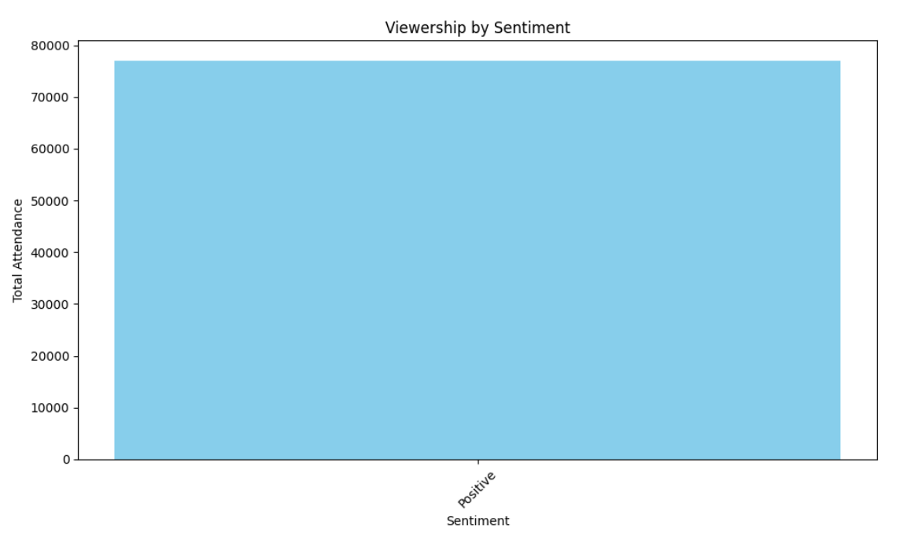

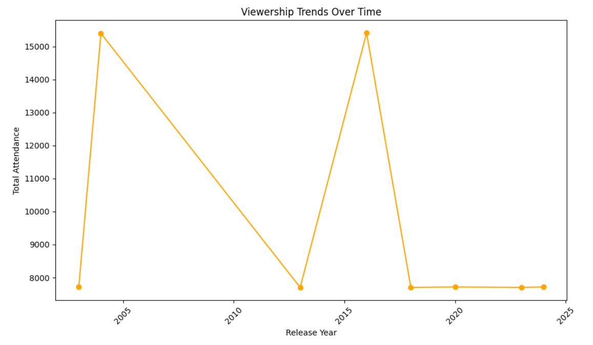

· **Task 3: Visualization of Geographic Viewership**

* **Status:** Completed
* **Details:**
  + Created bar charts to visualize:

**Total attendance by country**

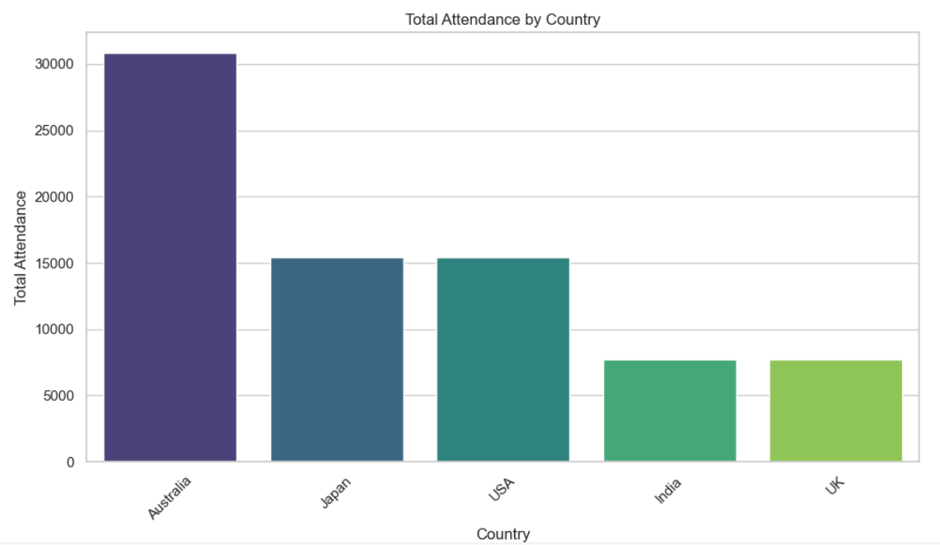.

**Average popularity by country.**

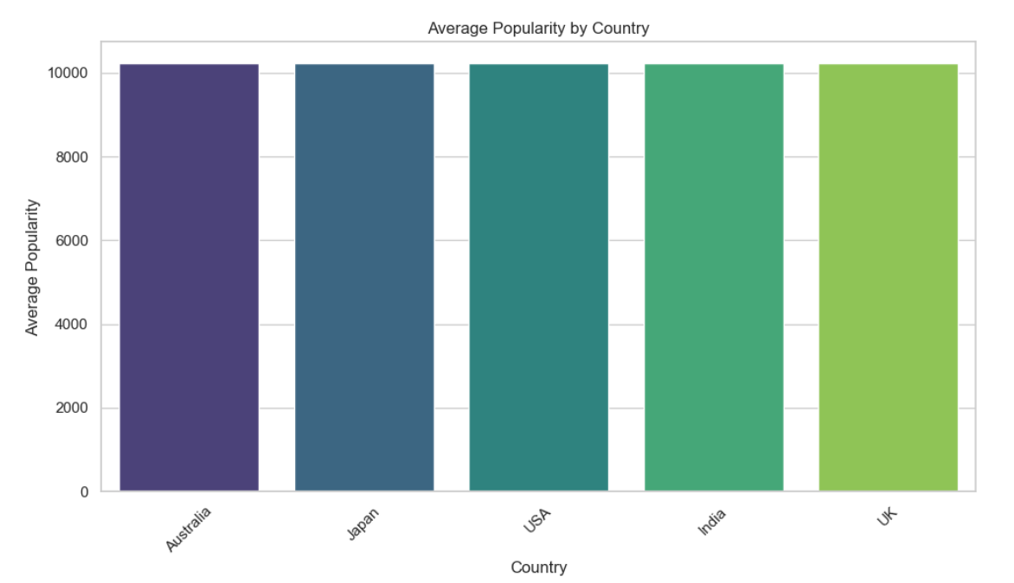

**Average valuation by country**

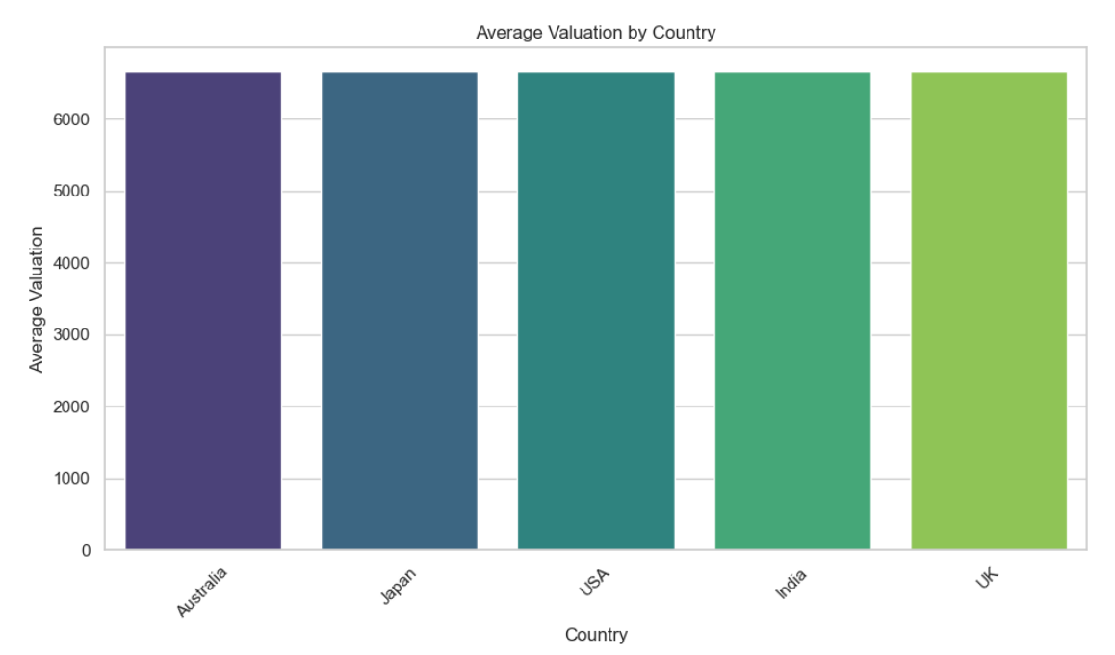

**Average vote average by country**

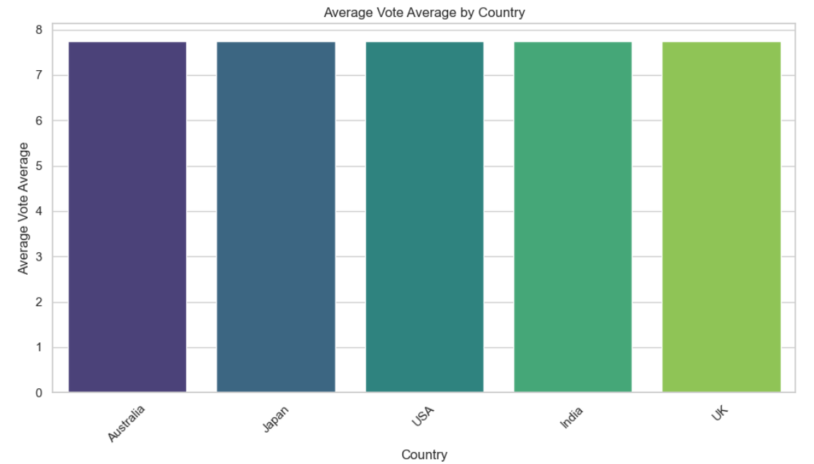

**Number of titles by country.**

# 

**Progress :**

· **Accomplishments:**

* Successfully incorporated geographic data into the analysis and visualized key metrics.
* Developed a clear understanding of viewership patterns across different countries.

· **Metrics:**

| **Country** | **Total Attendance** | **Avg Popularity** | **Avg Valuation** | **Avg Vote Average** | **Num Titles** |
| --- | --- | --- | --- | --- | --- |
| Australia | 30,830 | 10,224.28 | 6,655.96 | 7.742 | 4 |
| Japan | 15,413 | 10,224.28 | 6,655.76 | 7.742 | 2 |
| USA | 15,401 | 10,224.28 | 6,654.56 | 7.742 | 2 |
| India | 7,715 | 10,224.28 | 6,657.46 | 7.742 | 1 |
| UK | 7,703 | 10,224.28 | 6,655.06 | 7.742 | 1 |

# Challenges and Solutions :

· **Challenges Faced:**

* Encountered issues with missing or incorrect geographic data in the dataset.

· **Solutions Implemented:**

* Implemented data cleaning steps to ensure all necessary geographic information was included in the analysis.

# Next Steps :

· **Upcoming Tasks:**

* Continue exploring additional geographic dimensions such as demographics.
* Conduct further analysis on how different demographics engage with various regions.

· **Goals:**

* Aim to enhance visualizations and insights with demographic data, if available.

# Conclusion :

# Summary: The Geographic Viewership Analysis for the Entertainment Sector was successfully conducted, with significant insights gained through data visualization.

# **Acknowledgments**: Thank the audience for their time and attention.

# Instructions:

1. Use Google Docs. Single Column
2. TNR stands for Times New Roman: B - Bold
3. Use images as required with proper references
4. Use charts, tables as per your requirement.
5. Number of Pages: 2 to 8 for each task report.